Amber Chrischilles
MASS 360 Digital Design
Professor Rachael Hanel
8 May 2020
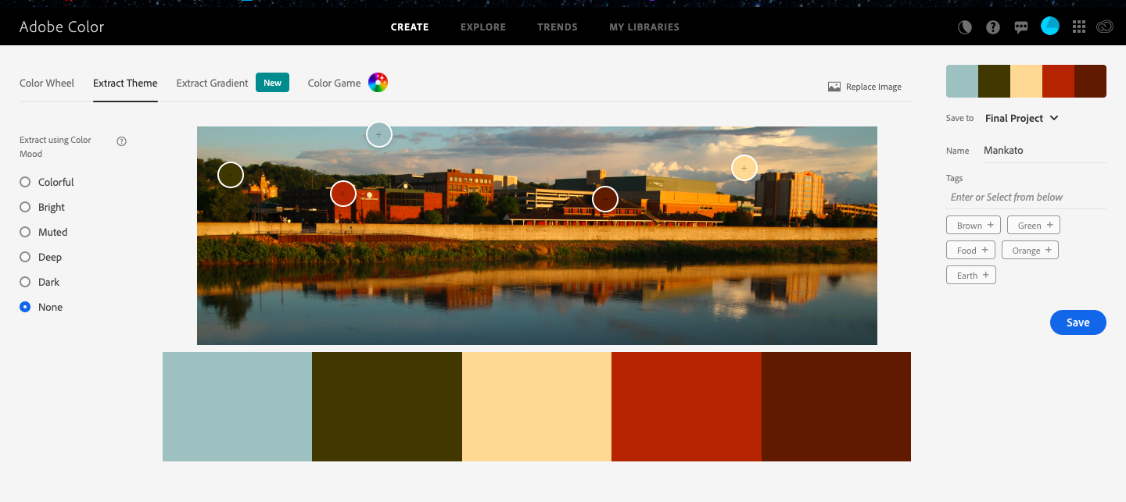
Final Project Summary

I used a color theme that I pulled off this picture of Mankato using the online Adobe color wheel:

 | C | M | Y | K | R | G | B
Blue | 37 | 14 | 22 | 0 | 163 | 191 | 191
Green | 58 | 58 | 95 | 59 | 64 | 54 | 7
Tan | 0 | 16 | 45 | 0 | 254 | 215 | 152
Light Red | 24 | 89 | 100 | 18 | 166 | 54 | 13
Dark Red | 38 | 84 | 92 | 58 | 89 | 32 | 11

I initially wanted my project to look more vibrant and have festival-like or neon colors. However, when I was making my logo, the vibrant colors were not looking good together. So, that’s when I had the idea to pull colors off a picture of Mankato. I feel like it gives off a very earthy and mellow tone to it. Looking at my color theme, you obviously can’t tell that the colors were taken from a picture of Mankato, but I thought the idea behind it made it special. The colors also remind me of fall which works well because the event is scheduled for September. By that time, Mankato might have a lot of the same colors as my color theme.
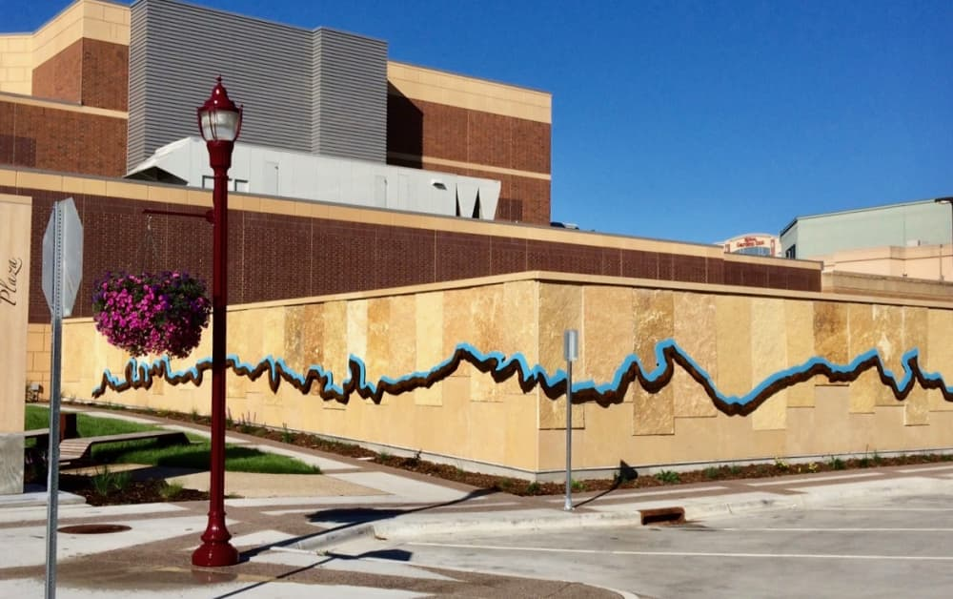
After looking up Mankato landmarks, I got the idea to incorporate the river near Mankato from this picture:
I used Illustrator to create the river line with the curvature tool. I then copied the line and pasted it so that it could resemble sheet music. To some people, especially residents of Mankato, the river line might be recognizable. However, for some, it might take some explaining for them to understand that it’s a river line. So, making the river line resemble sheet music was a good back-up design idea in case people couldn’t tell what the line means. I also thought it was a good way to combine Mankato and music. I also used Illustrator to create the music notes and to type the title of the event on the river line. I used a lot of kerning and tracking to try to make the spacing and readability better.
For Photoshop, I explored a few tools that I hadn’t tried out before. I used the spot healing brush to eliminate unwanted background spots. I tried to get a photo of each artist with a black or dark background so that they would look better together. I also explored the dodge and burn tool. On darker photos or photos with shadows, I used the dodge tool to lighten up the pictures in certain spots. On lighter photos, I used the burn tool to make it darker or to add more contrast. I also used the crop tool to eliminate unwanted background space.
In InDesign, I used a lot of the basic tools that I had been using in the past, such as the rectangle and oval tool. I also adjusted the kerning and tracking of some of my text to make it more spread out. In order to make the colors work better together, I adjusted the tint of my tan color in InDesign. I also rounded the corners of some of my shapes or textboxes. I also used the frame and rectangle tool to layout my photos nicely.

